Greece launches a national funding scheme for Clean Sky activities

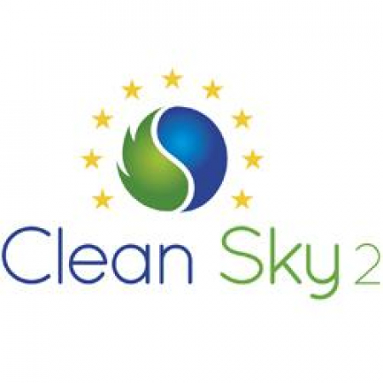

26 July 2019

Greece pre-announces a funding scheme within the framework of the Memorandum of Understanding (MoU) signed between the General Secretariat for Research & Technology (GSRT) and Clean Sky 2. Within this framework, interested Greek entities are encouraged to submit proposals under the 10th Call for Proposals (CfP10) launched by Clean Sky 2, and propose complementary activities via Part C of the application form. They will now be able to take advantage of funding complementarities between Clean Sky 2 calls and the ESIF funds managed by the GSRT in the framework of the Operational Program for Competitiveness, Entrepreneurship and Innovation (O.P. EPAnEK) 2014-2020.   
    
Proposals of purely Greek consortia that were submitted under the Calls for Proposals issued after the signing of the MoU (CfP07, CfP08 and CfP09) will also be considered for funding as long as they have been placed in the reserve list, comply with the priorities of the national RIS3 strategy, and are considered as complementary and contributing to Clean Sky 2 objectives. The same provisions will apply to reserve list proposals submitted by purely Greek consortia, in the framework of the current 10th Call (CfP10) launched by Clean Sky 2.   
    
The total budget earmarked by the GSRT for this pre-announcement is €2 million (public spending), co-funded by the European Regional Development Fund (ERDF) under the «Competitiveness – Entrepreneurship – Innovation» Operational Programme (EPAnEK) 2014-2020.   
    
For more information please refer to the [attached file](https://www.cleansky.eu/sites/default/files/inline-files/CS2JU_PREANNOUNCMENT_JUNE2019_en.pdf) and the [GSRT website](http://www.gsrt.gr/central.aspx?sId=125I490I1407I646I516590&olID=777&neID=965&neTa=10041_112156_1&ncID=0&neHC=0&tbid=0&lrID=2&oldUIID=aI777I0I119I428I1089I0I3&actionID=load&JScript=1).